**E-BikeKit™ Front 500w Geared Hub Motor**

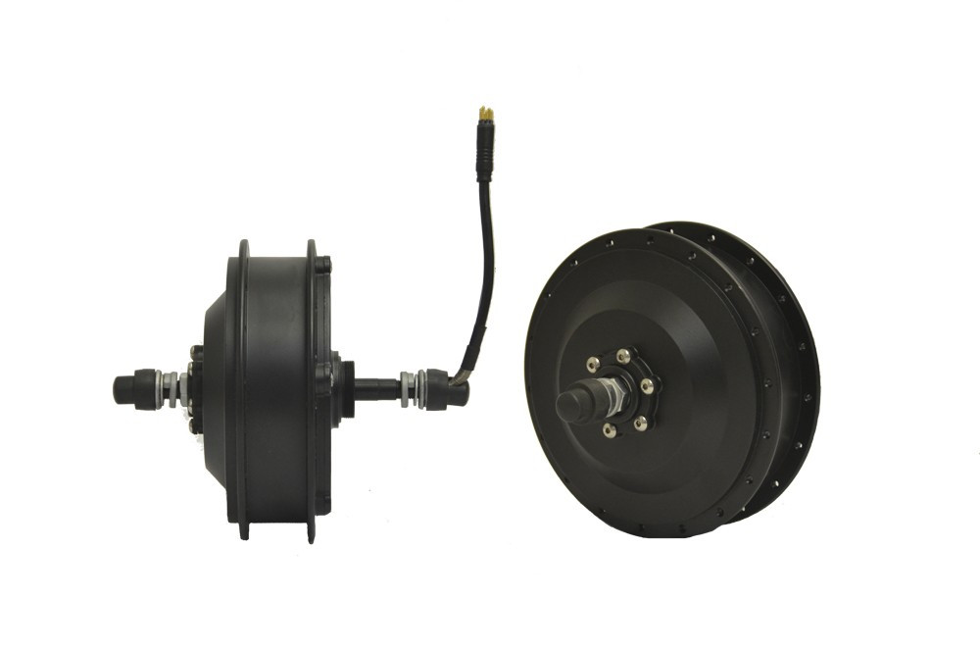

Internal 5:1 planetary gear hub motor with clutch. The clutch in the geared motor offers zero drag when pedaling and not engaging battery power. This motor is more efficient, resulting in increased range (especially with "start/stop" riding), has more starting torque, and has greater hill-climbing ability than a Direct-Drive motor of equal power rating

* Performance Geared Motor
* 20 mph at 36 Volt / 26 mph at 48 Volt
* Small, Lightweight, no Drag

**Brand**: Electric Bike Technologies  
**Type**: Internally Geared (brushless, disc brake compatible)  
**Power**: 500w nominal / >750w@36v / >1000 @48v  
**Max Torque:** 75N-m @36v / 84N-m @48v  
**Max RPM:** 259 @36v **/** 320 @ 48v  
**Cable**: 8" axle exit, 3-phase / 5 hall effect  
**Connector**: Round 8-pin 13/32" (10.4mm)  
**Weight**: 9.4lbs (4.26kg)  
**Warranty**: 1 Year (up to 48v - 300lb max load)